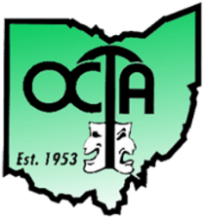
Ohio Community Theatre Association Date: June 24th, 2023
Northwest Regional Festival

Hosted By: Owens Community College
Center for Fine and Performing Arts
30335 Oregon Road Perrysburg, OH 43551

Registration Section One form should be completed for each cast, crew, technical member, and guest of the theatre. See bottom for submission details.

Name _________________________________________________ Zip Code ___________________________

Email Phone _____________________________

Are you participating in an excerpt? yes no If yes, name of theatre

Admission- $15 (Max Fee $300 for group) Total Amount (this form) _________ Your Check Number _________

Deadline for excerpt cast and crew registration is May 27, 2023.

By registering for the OCTA Northwest Regional Festival, I understand that I, and members of my party, may be included in photos or videos taken at the event and all media will become the property of the Ohio Community Theatre Association (OCTA), and I hereby irrevocably authorize OCTA to edit, alter, copy, exhibit, publish, or distribute these photos/videos for any lawful purpose.

Please make checks payable to “OCTA Northwest Region” and mail to: Rose Roberts 705 Clifton Blvd. Toledo, OH 43607 Questions or Concerns: Please email Rose Roberts at rosemroberts23@gmail.com

X
Signature of Theatre Member or Audience Guest (if electronic, please type full name)

