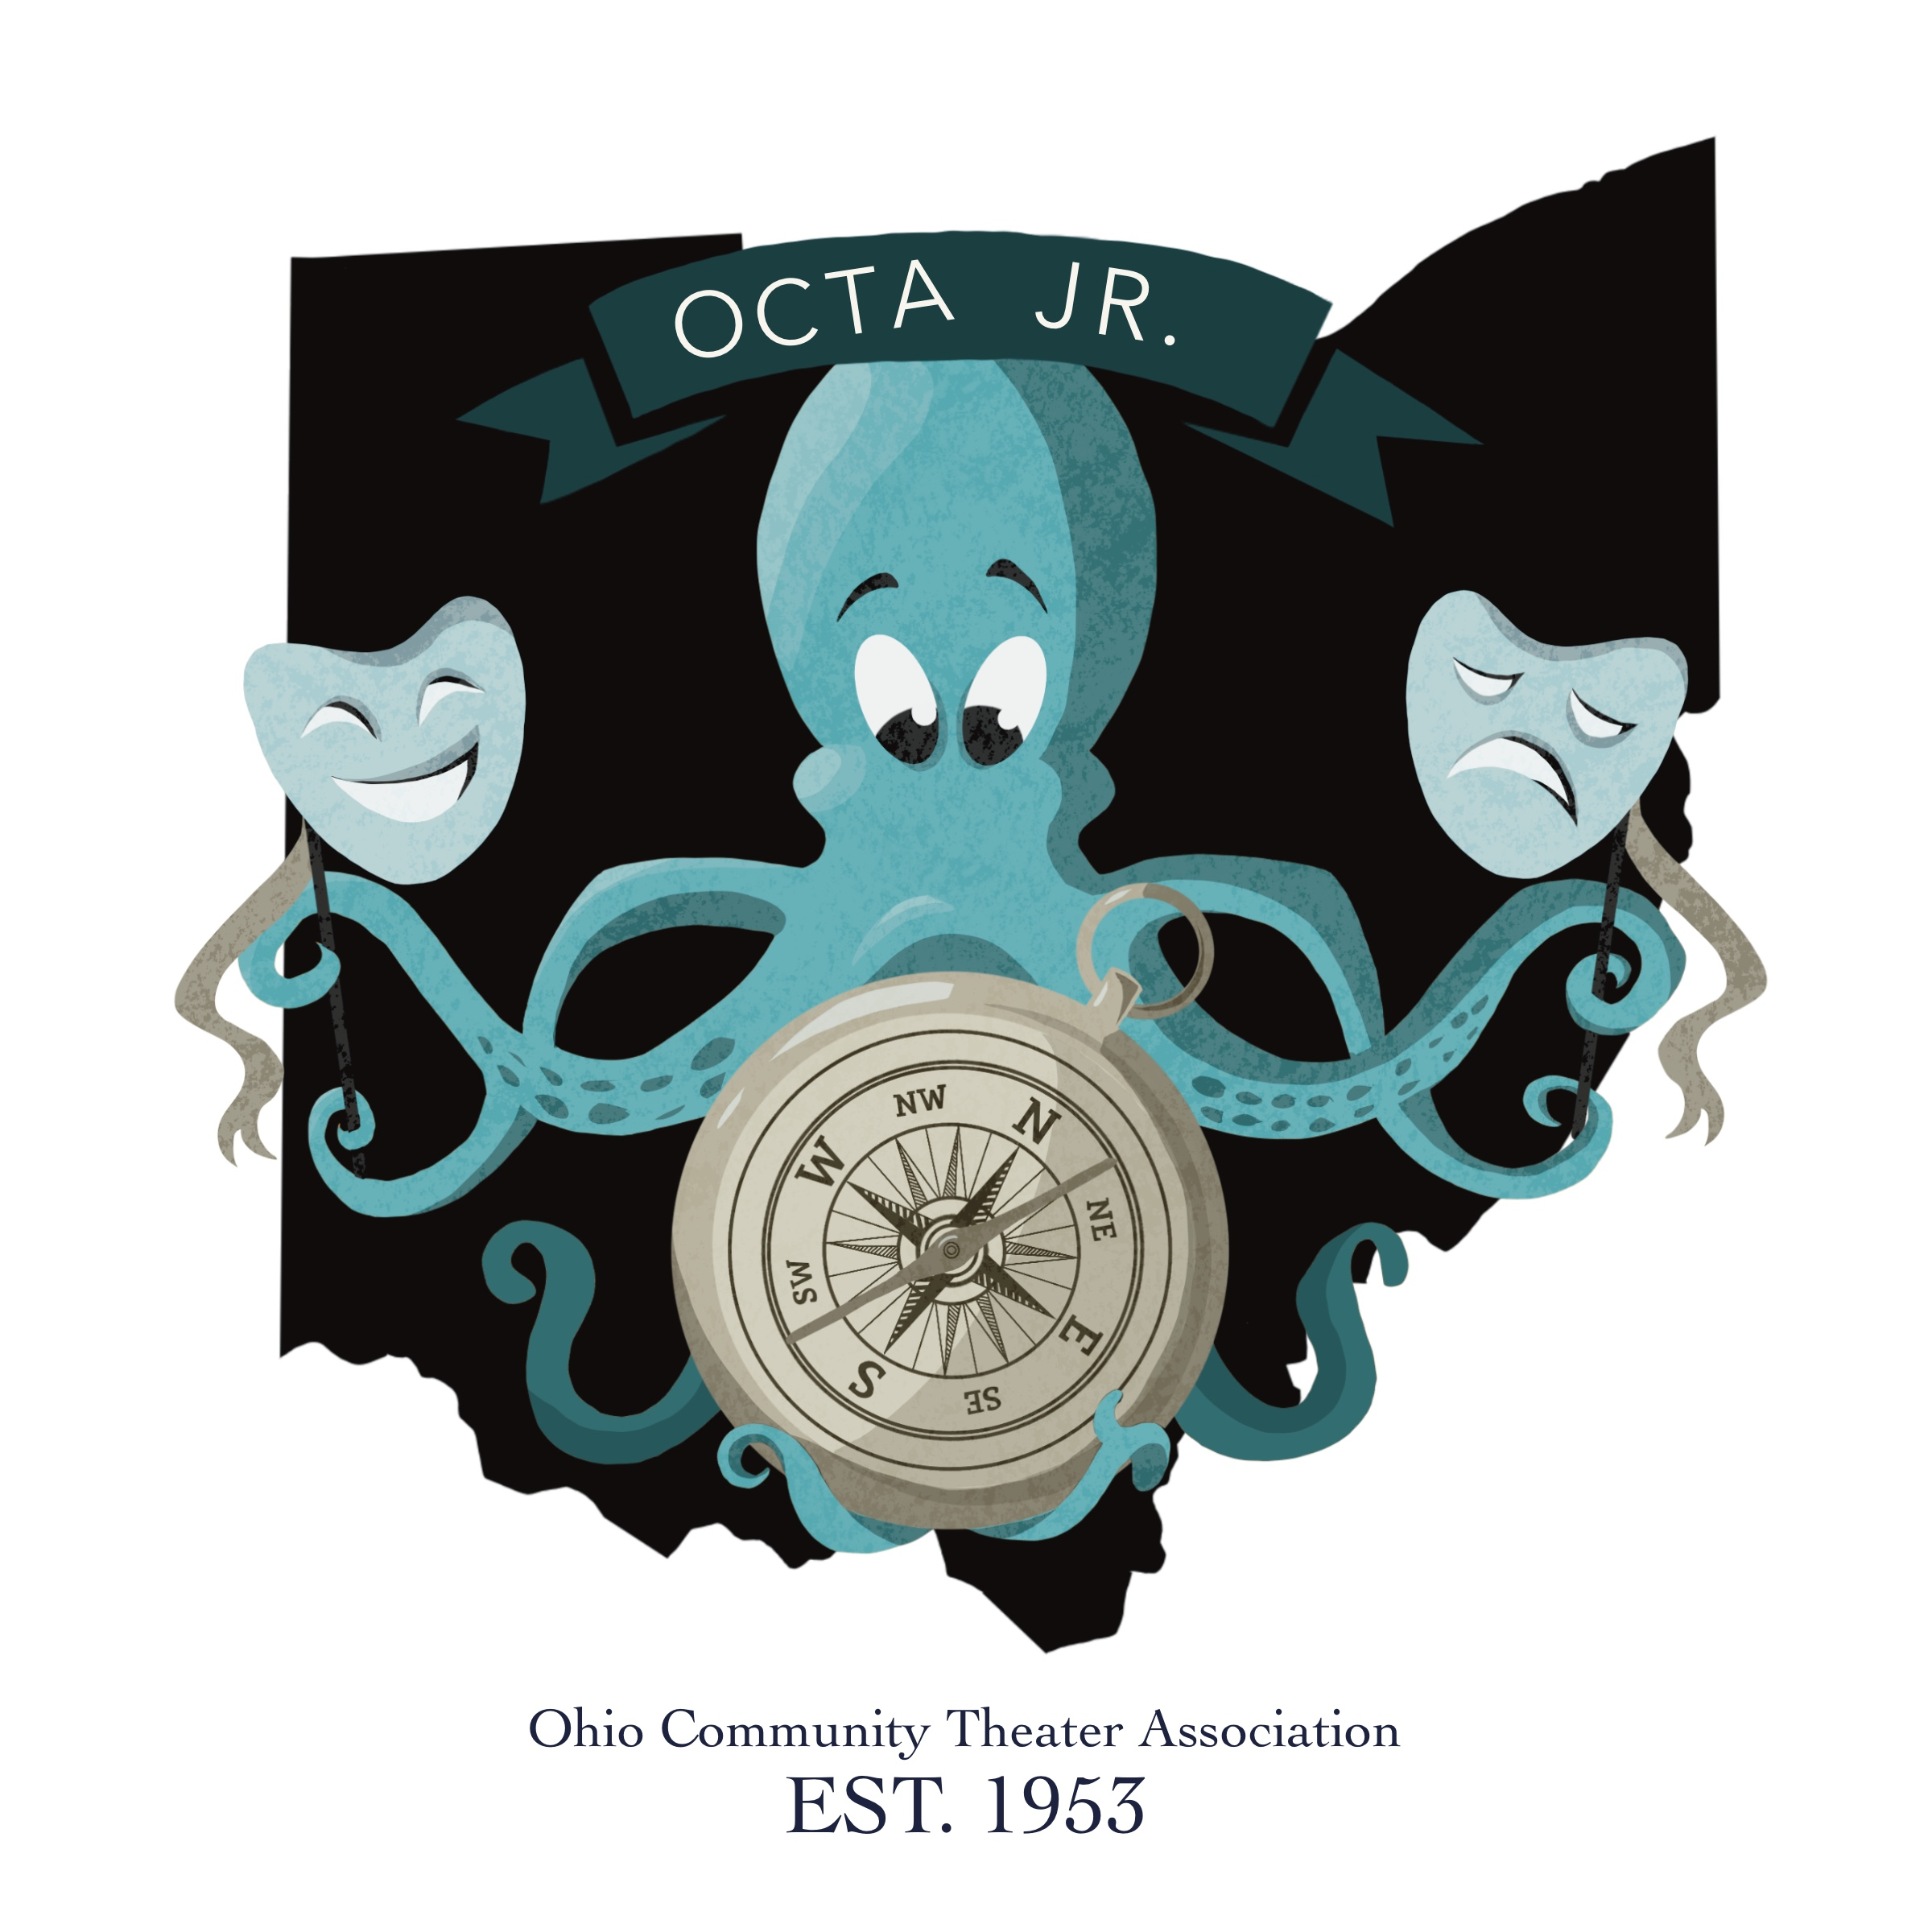
OCTA Fest, Jr. 2023
Youth Theatre State Festival
Dear OCTA Member Theatre:
On behalf of the Board of Directors of the Ohio Community Theatre Association, I am pleased to inform all theatres on the OCTA Fest Jr., a festival of excerpts focusing on youth/children’s theatre. We are pleased to announce that we will be at the beautiful Knox Memorial Auditorium in Mount Vernon, OH, for the 15th annual festival on July 29, 2023. (If more theaters enter, we may have to extend to a two-day event).
We believe this festival for youth/children’s theatre will help us deliver on one aspect of our organization’s stated purpose: to promote excellence and creativity in live theatre by providing educational opportunities for growth in artistic and technical aspects of live theatre. We want to create an exciting opportunity for member theatres to learn from one another and to support each other’s efforts toward excellence – all in the context of one of the most demanding and satisfying forms of art known to humanity: youth/children’s theatre.
Enclosed you will find a packet of information to assist theatres who wish to apply to participate in OCTA Fest, Jr. 2023. The packet includes a.) OCTA Fest, Jr. rules; b.) OCTA Fest, Jr. Technical Information; and c.) a Theatre Application Form. PLEASE RETURN THE THEATRE APPLICATION FORM BEFORE JUNE 15, 2023.
Theatres who sign-up to participate in the festival will later receive an additional packet which includes: a warranty form; a substitution form; a sample letter to request clearance; and a theatre registration form, each of which must be completed by July 15th, 2023, in advance of the festival.
The cost for participating theatres is only $150.00. That cost includes registration for the entire cast of the excerpt, plus SIX (6) additional staff/crew members. If your theatre is planning to pay for any additional people, those names need to be provided BEFORE the day of the festival, so a name badge can be made and placed in the packet you will receive upon your arrival at the festival. This will help alleviate the confusion at the Registration Table the day of the event.
A reminder: OCTA has always valued the opportunities a festival of excerpts provides for attending members to learn from each other. Consequently, the registration provides admission to the entire festival of excerpts for everyone registered. We make a practice of NOT offering half-day or single-excerpt registration.
WRISTBANDS WILL BE AVAILABLE FOR PURCHASE BY AUDIENCE MEMBERS
AT THE REGISTRATION TABLE THE DAY OF THE EVENT FOR A COST OF $15. PER PERSON
If you have a youth/children’s program in your theatre, we hope you’ll consider being one of our excerpt participants. To apply, complete and return the enclosed Theatre Application Form to the OCTA Fest, Jr. Chair, at the address listed below. APPLICATIONS POSTMARKED LATER THAN JUNE 15, 2023, WILL NOT BE ACCEPTED.
If you are contemplating a youth/children’s program in your theatre, we hope you will attend the festival to gain inspiration and knowledge from the excellent efforts of others.
If you have any questions, please do not hesitate to contact me.
Sincerely,
Bruce Jacklin, OCTAFest Jr. 2023
C: 740-501-8589
E: brucejacklin@gmail.com

