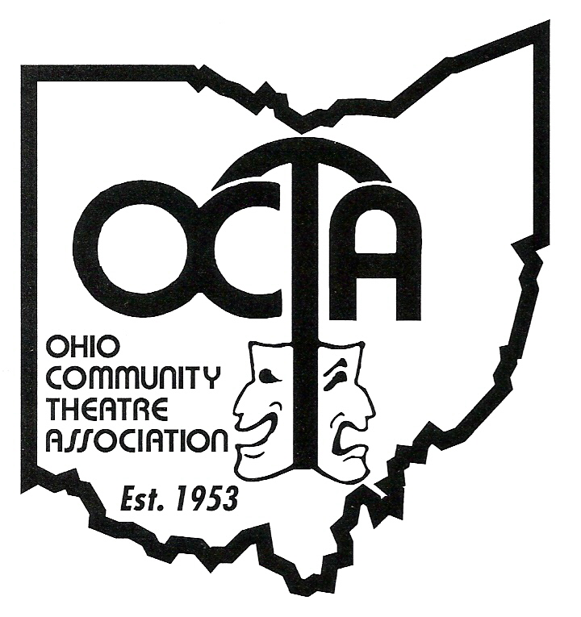
Please fill in the registration form below and return by Saturday, June 14th, 2025
(Fill in completely by typing or printing the appropriate information.)

Name: ___________________________________ Name for badge: _____________________
Address: _______________________________________ E-mail: _______________________
City: _________________________ State: _____ Zip: __________ Age: ___________
Phone: (______) _____-_______ Theatre Affiliation: _________________________________
□ I am the delegate for my theatre. □ I am the newsletter editor for my theatre.

Registration $10.00

10% Discount for OCTA Individual Members (# ____) ……………………………... _________

For grant purposes only:
____ Asian ____ African/American
____ Appalachian ____ Latino/Hispanic
____ Seniors Over 62 ____ Native Americans

Total Amount (this form)
Your Check Number

(Please use a separate form for each individual, however you may send one check per couple or for your entire group, just write the same check number on each form.)

□ Receipt requested (please note, you may receive this at the regional or after by mail!)
(A $20 fee will be charged for all returned checks)

Make check payable to West OCTA Region and mail this registration form(s) and check to: Michelle Peterson; 2005 Persimmon Way, Apt 2d, Tipp City Oh, 45371

If you have any questions, feel free to contact: Michelle Peterson at 614-425-9411 (cell) or mcpeterson8992@hotmail.com.

